## **Project proposal and Data**

Team 0504-06

## **1. Relations:**

● Restaurant(**resId**, resName, resStreet, resCity, resState, resPostalCode, resPhoneNo, resLat, resLong, resStars, resRevCNT, resPrice, resTransactionType, monStartTime, monEndTime, tuesStartTime, tuesEndTime, wedStartTime, wedEndTime, thurStartTime, thurEndTime, friStartTime, friEndTime, satStartTime, satEndTime, sunStartTime, sunEndTime, *stopId,* walktimeToRes)

● Category(**categoryId**, categoryName)

● Customer**(cusId**, cusName)

● Review(**revId**, revRating, revText)

● Shuttle(**busId**, busNo, busName, busFinalDest)

● Stop(**stopId**, stopName, stopLat, stopLong)

● Belong(***resId, categoryId***)

● Have(***busId, stopId***)

● Write(***cusId***, ***resId****,* ***revId***)

## **2. Functional Dependency:**

* resId → resName, resStreet, resCity, resState, resPostalCode, resPhoneNo, resLat, resLong, resStars, resRevCNT, resPrice, resTransactionType, monStartTime, monEndTime, tuesStartTime, tuesEndTime, wedStartTime, wedEndTime, thurStartTime, thurEndTime, friStartTime, friEndTime, satStartTime, satEndTime, sunStartTime, sunEndTime, stopId, walktimeToRes
* categoryId → categoryName
* cusId → cusName
* revId → revRating, revText
* busId → busId, busNo, busName, busFinalDest
* stopId → stopId, stopName, stopLat, stopLong
* resId, categoryId →
* revId, cusId, resId →

## **3. Normalizaton:**

* Restaurant(**resId**, resName, resStreet, resCity, resState, resPostalCode, resPhoneNo, resLat, resLong, resStars, resRevCNT, resPrice, resTransactionType, monStartTime, monEndTime, tuesStartTime, tuesEndTime, wedStartTime, wedEndTime, thurStartTime, thurEndTime, friStartTime, friEndTime, satStartTime, satEndTime, sunStartTime, sunEndTime, *stopId*, walktimeToRes) = 3NF
* Have(***busId, stopId***) = 3NF
* Category(**categoryId**, categoryName) = 3NF
* Customer(**cusId**, cusName) = 3NF
* Review(**revId**, revRating, revText) = 3NF
* Shuttle(**busId**, busNo, busName, busFinalDest) = 3NF
* Stop(**stopId**, stopName, stopLat, stopLong) = 3NF
* Belong(***resId, categoryId***) = 3NF
* Write(***cusId***, ***resId****,* ***revId***) = 3NF

## **4. Business rules:**

[R1] When a stop is deleted from the database, restaurants under its coverage and the walktime between them corresponding to the nearest stop should be deleted in the database.

[R2] When a stop is changed in the database, restaurants corresponding to the nearest stop should be updated accordingly.

[R3] When a stop is deleted from the database, the corresponding information in the shuttle should also be deleted.

[R4] When a stop is updated in the database, the corresponding information in the shuttle should be updated accordingly.

[R5] When a restaurant is no longer in the database, the corresponding category information should be deleted from the database.

[R6] When a category is deleted from the database, the corresponding restaurant cannot be deleted in the database.

[R7] When a category of restaurants is changed in the database, the corresponding restaurant information should be changed accordingly.

[R8] When a customer is deleted or changed his information from the database, the restaurant and the review cannot be deleted or changed in the database.

[R9] When a restaurant is deleted or changed in the database for some reason, reviews which customers wrote for it cannot be deleted or changed in the database.

[R10] When a review is deleted from the database, the corresponding restaurant and customer information should be changed accordingly.

[R11] When a review is being written or modified in the database, the restaurant and the review cannot be deleted or changed in the database.

[R12]When a restaurant changes information in the database, the corresponding category to the restaurant should be changed accordingly.

[R13] When a shuttle line doesn’t run anymore and is deleted from the database, the corresponding stop info should be deleted.

[R14] When a shuttle line is changed in the database, the corresponding stop info should be updated accordingly.

## **5. Referential integrity:**

|  |  |  |  |  |  |  |  |
| --- | --- | --- | --- | --- | --- | --- | --- |
| Relation | Foreign Key | Base Relation | Primary Key | Business Rule | Constraint: ON DELETE | Business Rule | Constraint: ON UPDATE |
| Restaurant | stopId | Stop | stopId | R1 | CASCADE | R2 | NO ACTION |
| Have | stopId | Stop | stopId | R3 | CASCADE | R4 | CASCADE |
| Have | busId | Shuttle | busId | R13 | CASCADE | R14 | CASCADE |
| Belong | resId | Restaurant | resId | R5 | CASCADE | R12 | CASCADE |
| Belong | categoryId | Category | categoryId | R6 | NO ACTION | R7 | CASCADE |
| Write | cusId | Customer | cusId | R8 | NO ACTION | R8 | NO ACTION |
| Write | resId | Restaurant | resId | R9 | NO ACTION | R9 | NO ACTION |
| Write | revId | Review | revId | R10 | CASCADE | R11 | CASCADE |

## **6. Describe Sample Data:**

Every table in the database has been described using a few rows of the dataset.

* **Restaurant**









Text Example:

Restaurant('ZPQD0vQIzZIovtHieUEDKA', 'Frisch's Big Boy', '12150 Mason Montgomery Rd', 'Cincinnati', 'OH', '45249', '(513) 683-2680', 39.291615, -84.315287, 2.5, 19, 1, 'pickup', 6:00:00, 23:00:00, 6:00:00, 23:00:00, 6:00:00, 23:00:00, 6:00:00, 23:00:00, 6:00:00, 23:00:00, 6:00:00, 23:00:00, 7:00:00, 23:00:00, 10626, 7.38930987590275)

* **Have**

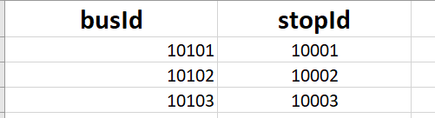

Text Example :

Have(10101, 10001)

* **Category**

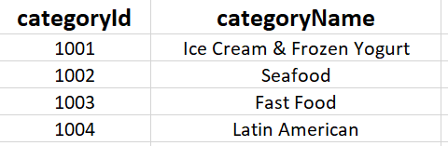

Text Example:

Category(1001, 'Ice Cream & Frozen Yogurt')

* **Customer**

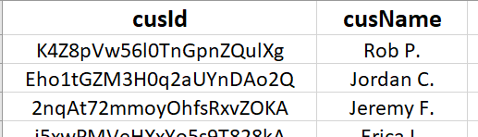

Text Example:

Customer('K4Z8pVw56l0TnGpnZQulXg', 'Rob P.')

* **Review**



Text Example:

Review('RAnoq4EBIpomrG8GQvXA-w', 5, 'On the run (Five Guys isn't fast food but...) No matter which one I go to...Good eats! It's like Mickey D's but Oh So Much Better! Five Guys is proof that...')

* **Shuttle**

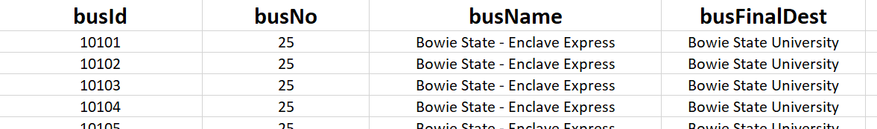

Text Example:

Shuttle(10101, 25, 'Bowie State - Enclave Express', 'Bowie State University')

* **Stop**

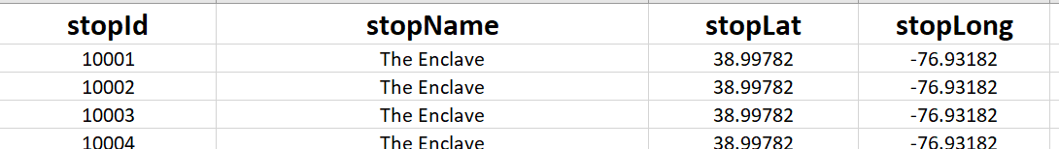

Text Example:

Stop(10001, 'The Enclave', 38.99782, -76.93182)

* Belong

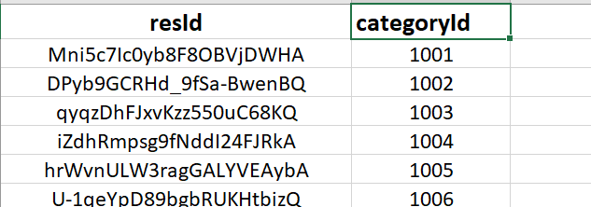

Text Example:

Belong('Mni5c7Ic0yb8F8OBVjDWHA', 1001)

* Write

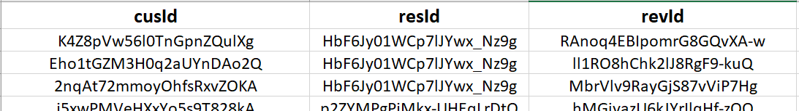



Text Example:

Write('K4Z8pVw56l0TnGpnZQulXg', 'HbF6Jy01WCp7lJYwx_Nz9g', 'RAnoq4EBIpomrG8GQvXA-w')